CPSLD Meeting
May 7 – 9, 2009
Hosted by University of Victoria

Venue:
University of Victoria
Cadboro Commons building, Campus View Room
The building is in quadrant D3 of this Campus map: http://www.uvic.ca/maps/2dmap.html

Directions:
By Transit http://www.uvic.ca/maps/busroutes.html
By Car http://maps.google.ca/
Parking on campus is $6.00 for all day. Permits available from dispensers located in all numbered lots outside Ring Road. Park in either Lot 1, located off Ring Road, or Lot 5, located off Sinclair Road.

Meals:
May 7 & 8 - Breakfast & Lunch hosted by University of Victoria (in Campus View room, Cadboro Commons building).

Dinner Thursday night at Il Terrazzo Ristorante
http://www.ilterrazzo.com/
RSVP to Cathrine Jansen by Monday, May 4th (ctjansen@uvic.ca)

Contacts:
Dana McFarland, University Librarian
CPSLD President
-----------------------------------------------------
Royal Roads University
2005 Sooke Road
Victoria, BC V9B 5Y2
Phone: (250) 391 2575
Email: Dana.McFarland@RoyalRoads.ca

Cathrine Jansen, Technical Services Secretary
McPherson Library, Technical Services
University of Victoria
Phone: 250-472-4989
Email: ctjansen@uvic.ca

Other Maps:

http://maps.google.ca/maps?f=q&source=s_q&hl=en&geocode=&q=university+of+victoria&sll=48.464723,-123.310717&sspn=0.011941,0.020431&ie=UTF8&start=10&z=14

Please see next pages for maps of:

the University of Victoria campus,
a smaller map of the campus area showing vicinity of Cadboro Commons building,
and a map of the 2nd floor of the Cadboro Commons building. Access the building from the stairs to easily locate
the Campus View Room.
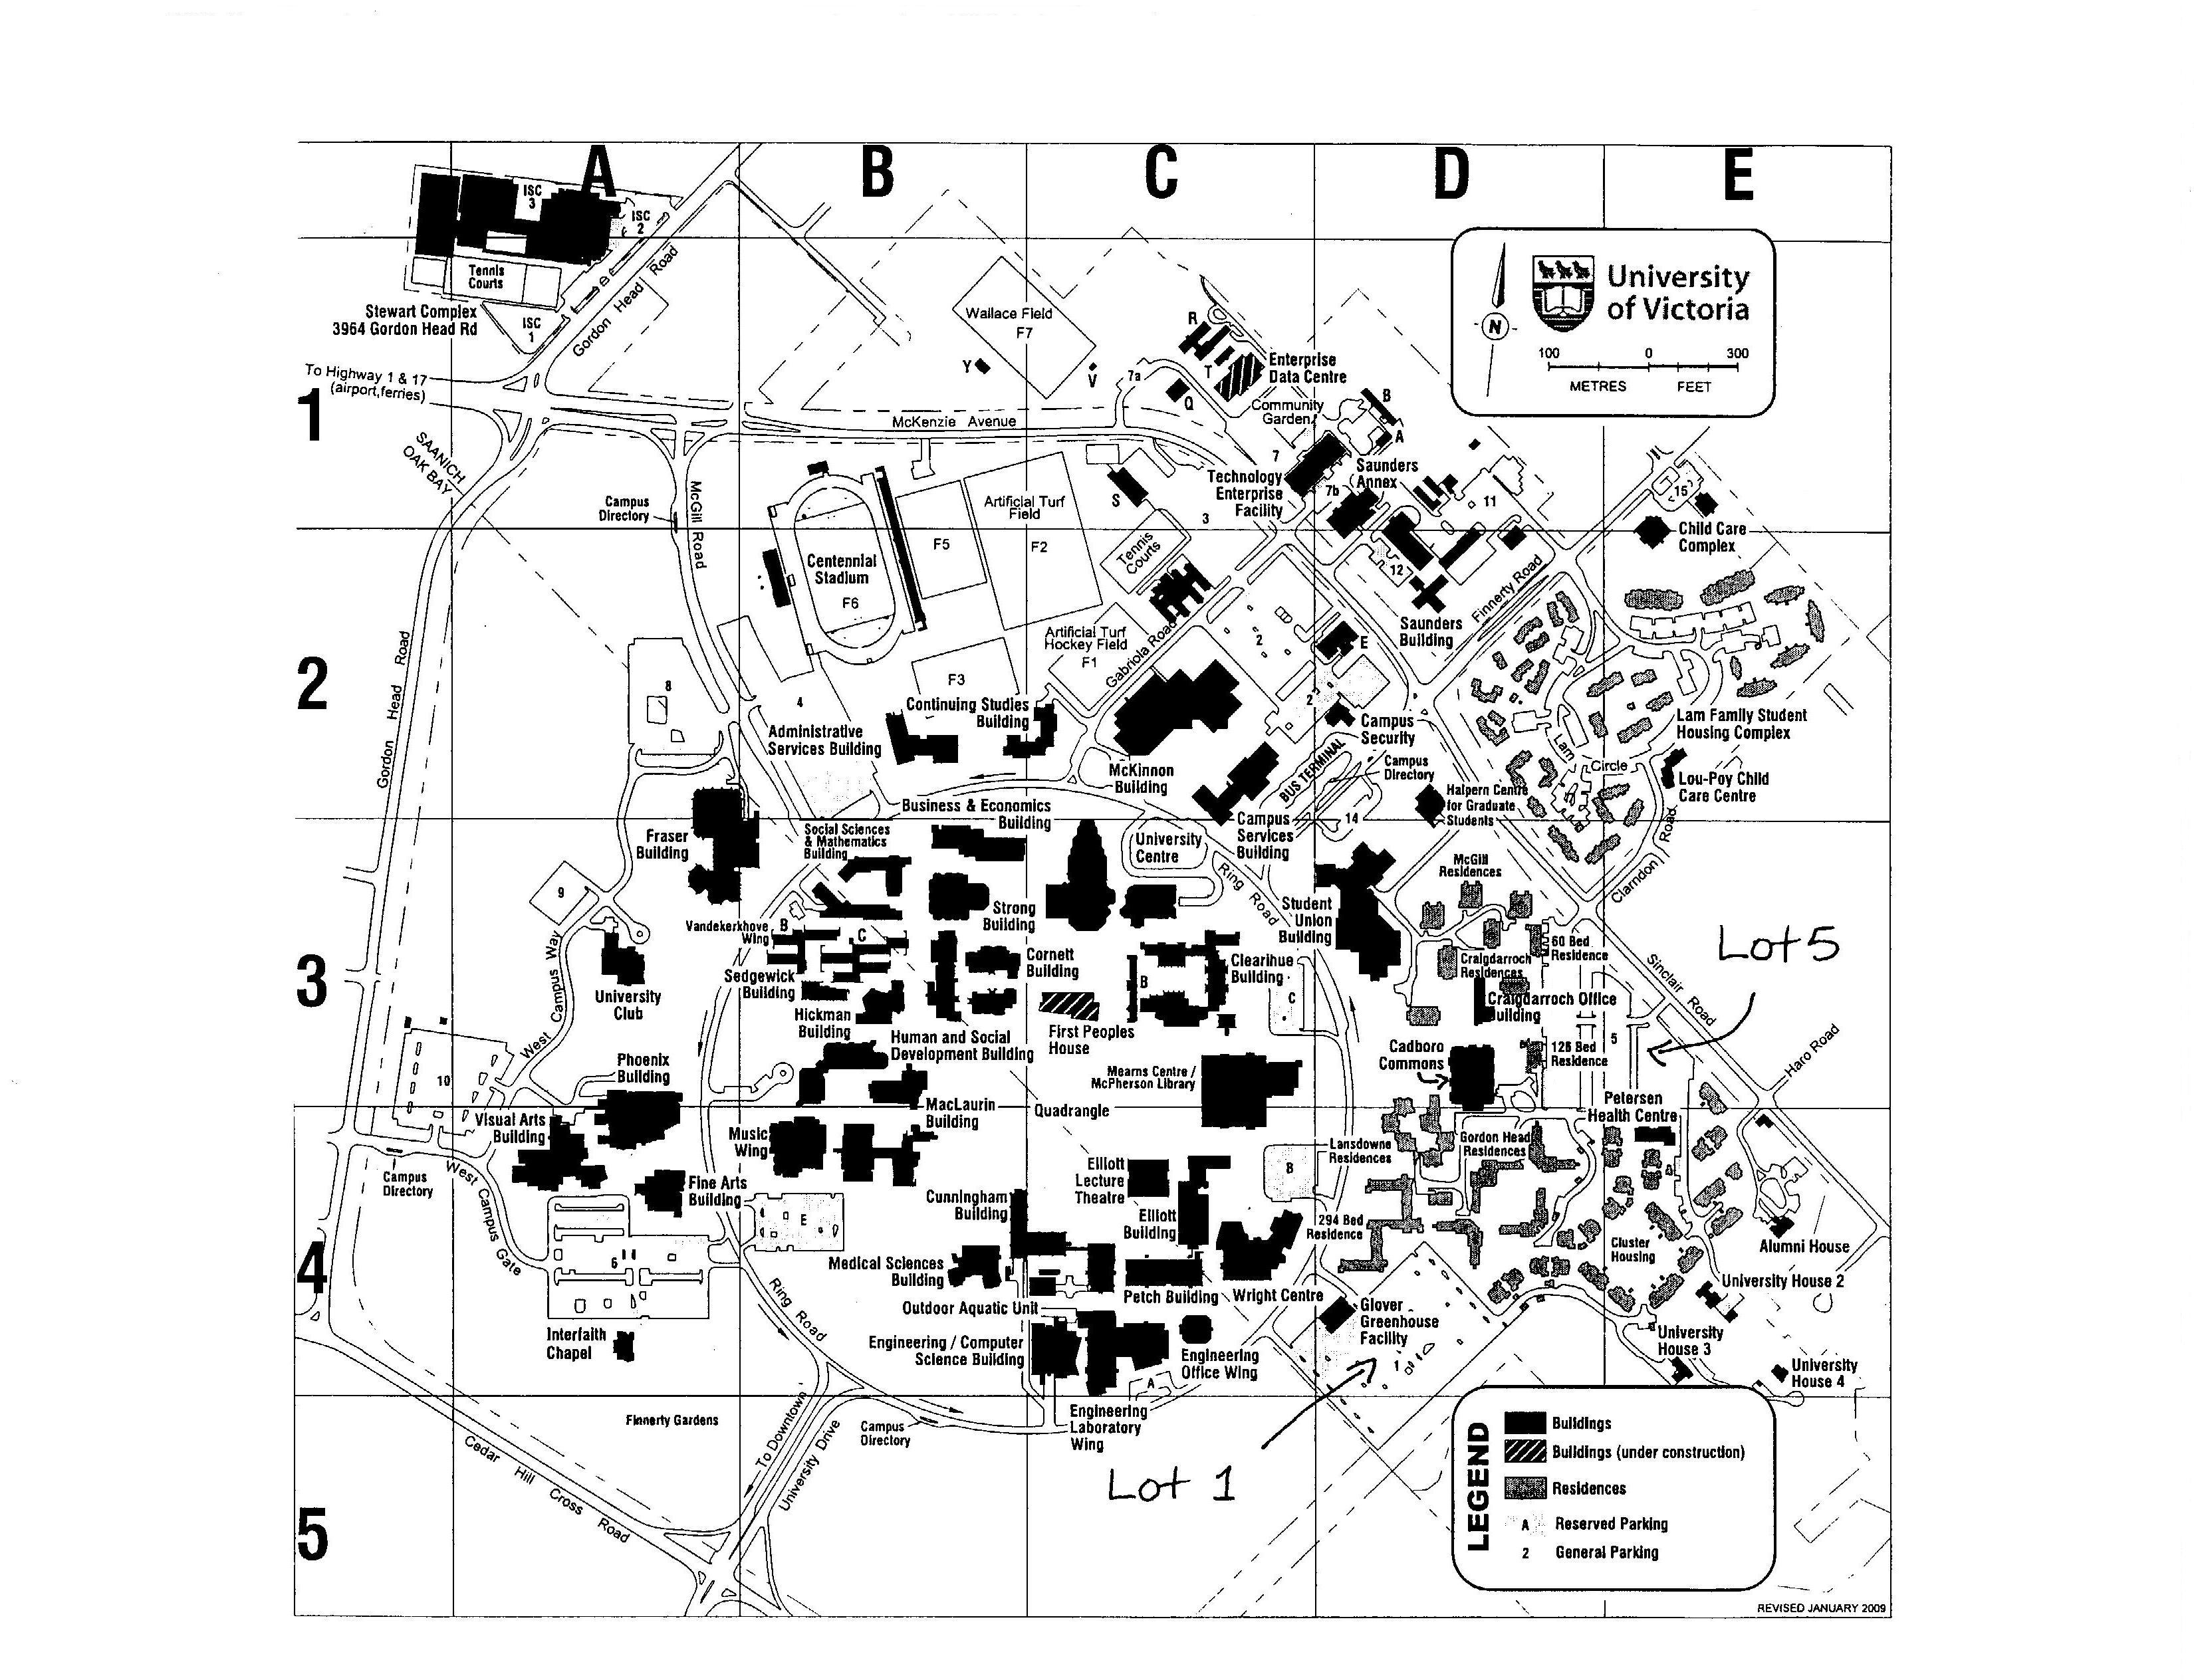
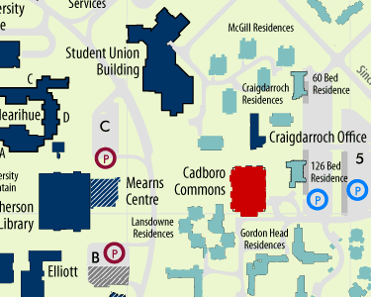

Lot 5 is visible on right edge of image above. Parking lot access is from Sinclair Road.

Lot 1 does not appear in above image but is located south of lot 5 towards the centre of the image.
Lot 1 is accessed off Ring Road.
